Unit 4-8051 memory, interrupts and timers/counters

8051 Memory Organization
The 8051 microcontroller's memory is divided into Program Memory and Data Memory. Program Memory (ROM) is used for permanent saving program being executed, while Data Memory (RAM) is used for temporarily storing and keeping intermediate results and variables.

Program Memory (ROM)
Program Memory (ROM) is used for permanent saving program (CODE) being executed. The memory is read only. Depending on the settings made in compiler, program memory may also used to store a constant variables. The 8051 executes programs stored in program memory only. code memory type specifier is used to refer to program memory.

8051 memory organization allows external program memory to be added. How does the microcontroller handle external memory depends on the pin EA logical state.

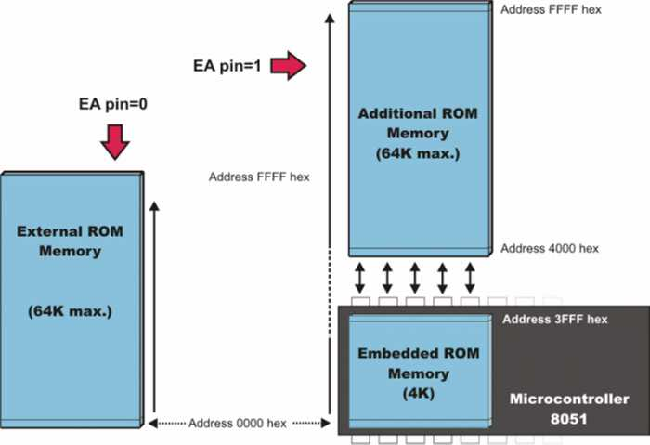

Internal Data Memory
Up to 256 bytes of internal data memory are available depending on the 8051 derivative. Locations available to the user occupy addressing space from 0 to 7Fh, i.e. first 128 registers and this part of RAM is divided in several blocks. The first 128 bytes of internal data memory are both directly and indirectly addressable. The upper 128 bytes of data memory (from 0x80 to 0xFF) can be addressed only indirectly.

Since internal data memory is used for CALL stack also and there is only 256 bytes splited over few different memory areas fine utilizing of this memory is crucial for fast and compact code. Memory block in the range of 20h to 2Fh is bit-addressable, which means that each bit being there has its own address from 0 to 7Fh. Since there are 16 such registers, this block contains in total of 128 bits with separate addresses ( Bit 0 of byte 20h has the bit address 0, and bit 7 of byte 2Fh has the bit address 7Fh).

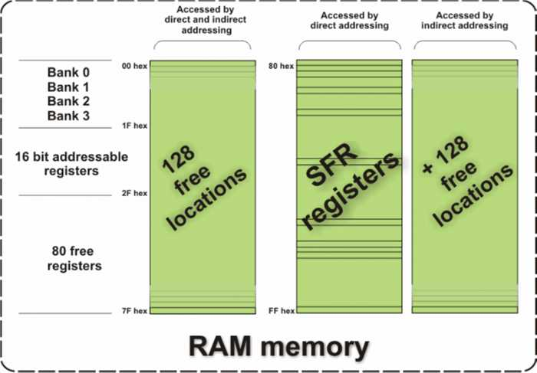

External Data Memory
Access to external memory is slower than access to internal data memory. There may be up to 64K Bytes of external data memory. Several 8051 devices provide on-chip XRAM space that is accessed with the same instructions as the traditional external data space. This XRAM space is typically enabled via proper setting of SFR register and overlaps the external memory space. Setting of that register must be manualy done in code, before any access to external memory or XRAM space is made.

Types of Memory
The 8051 has three very general types of memory. To effectively program the 8051 it is necessary to have a basic understanding of these memory types.
The memory types are illustrated in the following graphic. They are: On-Chip Memory, External Code Memory, and External RAM
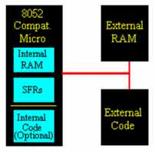
On-Chip Memory refers to any memory (Code, RAM, or other) that physically exists on the microcontroller itself. On-chip memory can be of several types, but we'll get into that shortly.
External Code Memory is code (or program) memory that resides off-chip. This is often in the form of an external EPROM.
External RAM is RAM memory that resides off-chip. This is often in the form of standard static RAM or flash RAM.
Code Memory
Code memory is the memory that holds the actual 8051 program that is to be run. This memory is limited to 64K and comes in many shapes and sizes: Code memory may be found on-chip, either burned into the microcontroller as ROM or EPROM. Code may also be stored completely off-chip in an external ROM

External RAM
As an obvious opposite of Internal RAM, the 8051 also supports what is called External RAM.
What External RAM loses in speed and flexibility it gains in quantity. While Internal RAM is limited to 128 bytes (256 bytes with an 8052), the 8051 supports External RAM up to 64K.

Interfacing-external RAM/ROM interface.

- The 8051 microcontroller has a well-defined memory architecture.
- Memory is divided into Program Memory (ROM) and Data Memory (RAM).
- Supports internal and external memory expansion.
- Program Memory (ROM)
  - Internal ROM: 4KB (in standard 8051)
  - External ROM: Up to 64KB (if needed)
  - Accessed using PSEN (Program Store Enable)
- Data Memory (RAM)
  - Internal RAM: 128 bytes
  - External RAM: Up to 64KB (accessed using MOVX instruction)
  - Divided into:
    - Register Banks (0-31 bytes)
    - Bit-Addressable RAM (32 bytes, 20H-2FH)
    - General-Purpose RAM (30H-7FH)
SFR
- Located in upper 128 bytes (80H-FFH).
- Used to control Timers, Serial Communication, Ports, Interrupts, etc.
- Examples:
  - P0-P3 (I/O Ports)
  - TCON (Timer Control)
  - SCON (Serial Control)
  - IE (Interrupt Enable)
Memory Interfacing in 8051
- External memory is interfaced using Address, Data, and Control signals.
- Two types:
  - External Program Memory (ROM): Accessed using PSEN.
  - External Data Memory (RAM): Accessed using RD & WR.
Interfacing External ROM
- Used when program size > 4KB.
- Address Bus (A0-A15) → ROM
- Data Bus (D0-D7) → ROM
- PSEN → ROM Output Enable (OE)
- ALE → Latch Lower Address
- EA (External Access): Set to 0 for full external ROM access.

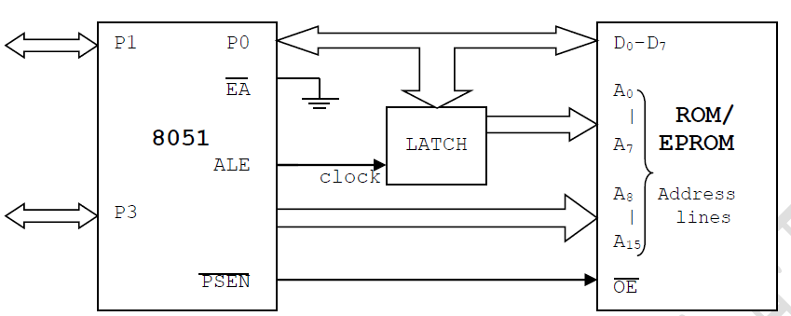
EXTERNAL ROM (PROGRAM MEMORY) INTERFACING
Figure 5.6.1 Interfacing of ROM/EPROM to 8051
- Port 0 is used as multiplexed data & address lines. It gives lower order (A7-A0) 8 bit address in initial T cycle & higher order (A8-A15) used as data bus.
- 8 bit address is latched using external latch & ALE signal from 8051.
- Port 2 provides higher order (A15-A8) 8 bit address.
- PSEN is used to activate the output enable signal of external ROM/EPROM.

EXTERNAL RAM (DATA MEMORY) INTERFACING
Figure 5.6.2 shows how to connect or interface external RAM (data memory) to 8051.
- Port 0 is used as multiplexed data & address lines.
- Address lines are decoded using external latch & ALE signal from 8051 to provide lower order (A7-A0) address lines.
- Port 2 gives higher order address lines.

- RD & WR signals from 8051 selects the memory read & memory write operations respectively.
Figure 5.6.2 Interfacing of RAM to 8051
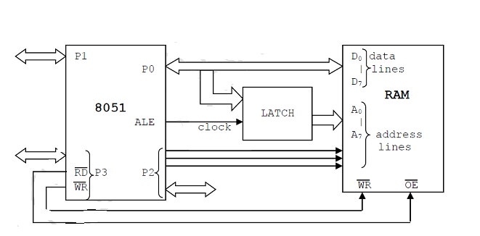

Note:RD & WR signals: generally P3.6 & P3.7 pins of port 3 are used to generate memory read and memory write signals. Remaining pins of port 3 i.e. P3.0-P3.5 can be used for other functions.

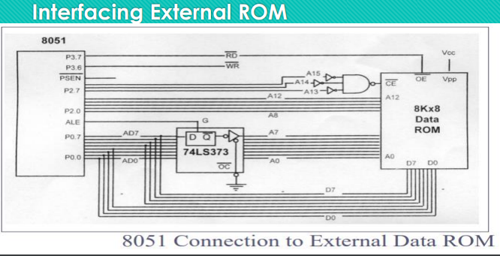
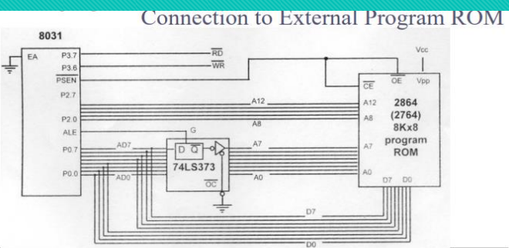

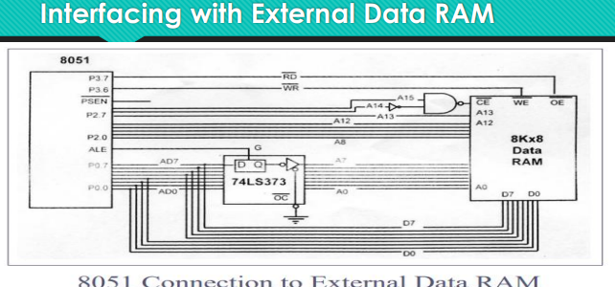

TIMERS AND COUNTERS

The 8051 CPU has a cycle time of 12 clock cycles per byte fetch. The 8051's clock source is an external crystal oscillator.
The 8051 provides two 16-bit timers/counters: Timer 0 and Timer 1. These versatile timers can be configured to operate in four distinct modes, each serving specific timing requirements.
The 8051 has two timers/counters, Timer 0 and Timer 1. They can be used as either timers to generate a time delay or as counters to count events happening outside the microcontroller. Both Timer 0 and Timer 1 are 16 bits wide. They are accessed as two separate registers of low byte and high byte.
Timer 0 (T0) Register:
Low byte register of T0 is called TL0 and high byte is called as TH0. These registers can be accessed like any other register. For example, MOV TL0, #3EH, will transfer data 3EH to TL0, and MOV A, TH0 will transfer content of TH0 to accumulator.
Timer 1 (T1) Register:
Low byte register of T1 is called TL1 and high byte is called as TH1. These registers are accessible in the same way as registers of Timer 0.
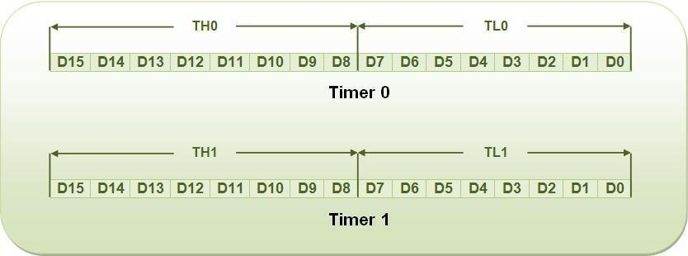
The following are timer related SFRs in 8051.
SFR Name
Description
SFR Address
TH0 Timer0 High Byte 8Ch
TL0 Timer0 Low Byte 8Ah
TH1 Timer1 High Byte 8Dh
TL1 Timer1 Low Byte 8Bh
TCON Timer Control 88h
TMOD Timer Mode 89h
Timers/Counters are used generally for:
a. Time reference
b. Creating delay
c.Wave form properties measurement
d. Periodic interrupt generation
e. Waveform generation
TMOD (Timer Mode) Register:
It is used to various timer operation modes of T0 and T1. It is an 8 bit SFR in which lower 4 bits are used for T0 and upper 4 bits are used for T1.
They are used to select timer mode. There are four modes of operation.
1. Mode 0 – 13-bit timer
2. Mode 1 – 16-bit timer/counter
3. Mode 2 – 8-bit auto-reload timer/counter
4. Mode 3 – Split timer.

C/T (clock/timer):
This bit is used to select timer hardware as a timer or counter. If this bit is set to 0, timer hardware act as a timer to generate time delay by counting internal clock pulse generated by the crystal oscillator. If the bit is set to 1, the hardware acts as a counter to count external clock pulse which represents an event.
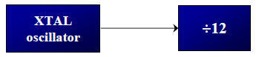

Timer in 8051 is used as timer, counter and baud rate generator. Timer always counts up irrespective of whether it is used as timer, counter, or baud rate generator: Timer is always incremented by the microcontroller. The time taken to count one digit up is based on master clock frequency.

If Master CLK=11.0592 MHz,
Timer Clock frequency = Master CLK/12 = 921.6 kHz
Timer Clock Period = 1.085 micro second
This indicates that one increment in count will take 1.085 micro second.

The two timers in 8051 share two SFRs (TMOD and TCON) which control the timers, and each timer also has two SFRs dedicated solely to itself (TH0/TL0 and TH1/TL1)

8051 Interrupts

8051 interrupt vector table
Vector Address: This is the address where the controller jumps after the interrupt to serve the ISR (interrupt service routine).

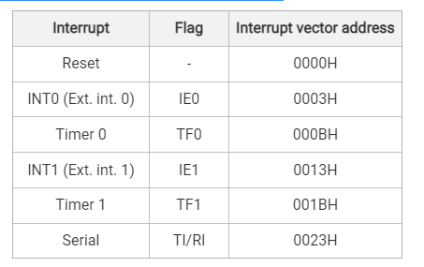
Reset
Reset is the highest priority interrupt, upon reset 8051 microcontroller start executing code from 0x0000 address.
8051 Internal interrupt (Timer Interrupt)
8051 mcu has two internal interrupts namely timer0 and timer1. Whenever timer overflows, timer overflow flags (TF0/TF1) are set. Then the microcontroller jumps to their vector address to serve the interrupt. For this, global and timer interrupt should be enabled.
8051 Serial interrupt
8051 mcu has a serial communication port and have related serial interrupt flags (TI/RI). When the last bit (stop bit) of a byte is transmitted, the TI serial interrupt flag is set, and when the last bit (stop bit) of the receiving data byte is received, the RI flag gets set.
8051 Interrupt priority
Priority to the interrupt can be assigned by using the interrupt priority register (IP)
Interrupt priority after Reset:
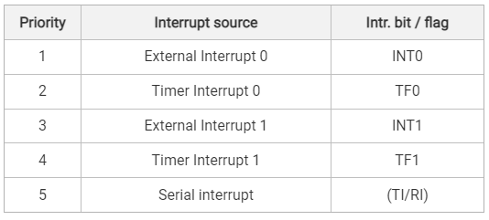
In the table, interrupts priorities upon reset are shown. As per 8051 interrupt priorities, the lowest priority interrupts are not served until the microcontroller is finished with higher priority ones. In a case when two or more interrupts arrive microcontroller queues them according to priority.

External interrupts in 8051
- 8051 has two external interrupt INT0 and INT1.
- 8051 controller can be interrupted by external Interrupt, by providing level or edge on external interrupt pins PORT3.2, PORT3.3.
- External peripherals can interrupt the microcontroller through these external interrupts if global and external interrupts are enabled.
- Then the microcontroller will execute current instruction and jump to the Interrupt Service Routine (ISR) to serve to interrupt.
- In the polling, method the microcontroller has to continuously check for a pulse by monitoring pin, whereas, in the interrupt method, the microcontroller does not need to poll. Whenever an interrupt occurs microcontroller serves the interrupt request.
8051 mcu has two types of external interrupts of activation level
- Edge triggered (Interrupt occur on rising/falling edge detection)
- Level triggered (Interrupt occur on high/low-level detection)
In 8051 mcu, two types of activation levels are used. These are,
Low level triggered
Whenever a low level is detected on the INT0/INT1 pin while global and external interrupts are enabled, the controller jumps to interrupt service routine (ISR) to serve interrupt.
Falling edge triggered
Whenever falling edge is detected on the INT0/INT1 pin while global and ext. interrupts are enabled, the controller jumps to interrupt service routine (ISR) to serve interrupt.
There are lower four flag bits in the TCON register required to select and monitor the external interrupt type and ISR status.

Programming the 8051 Timers

1.Generating a Delay using Timer Mode 1 (16-bit mode)

MOV TMOD, #01H ; Select Timer 0, Mode 1 (16-bit)
MOV TH0, #0xFC ; Load high byte
MOV TL0, #0x66 ; Load low byte (for 1ms delay)
SETB TR0 ; Start Timer 0
HERE: JNB TF0, HERE; Wait until overflow (TF0 = 1)
CLR TR0 ; Stop Timer
CLR TF0 ; Clear overflow flag

2. Using Timer in Mode 2 (8-bit auto-reload)
MOV TMOD, #20H ; Select Timer 1, Mode 2
MOV TH1, #0xFD ; Load auto-reload value
MOV TL1, #0xFD ; Load initial value
SETB TR1 ; Start Timer 1
HERE: JNB TF1, HERE; Wait for overflow
CLR TF1 ; Clear overflow flag

3.Using Timer as an Event Counter
MOV TMOD, #05H ; Select Timer 0 as Counter, Mode 1
SETB TR0 ; Start Counter
HERE: JNB TF0, HERE; Wait for event count overflow
CLR TF0 ; Clear overflow flag

4.Mode 3 – Split Timer Mode
- In Mode 3, Timer 0 is split into two independent 8-bit timers.
- Timer 1 loses functionality in this mode and cannot be used.

How Mode 3 Works:
- TL0 (Lower 8-bit timer) operates as a full 8-bit timer with its own control.
- TH0 (Higher 8-bit timer) acts as another independent 8-bit timer.
- Timer 1 remains inactive and cannot be used.

Setting Timer 0 in Mode 3:
- TL0 is controlled by TR0 and TF0.
- TH0 is controlled by TR1 and TF1 (Yes, TR1 and TF1, even though it is Timer 0).

Example Code for Split Timer Mode
MOV TMOD, #04H ; Set Timer 0 to Mode 3
MOV TH0, #0FFH ; Load TH0 (upper 8-bit timer)
MOV TL0, #0A0H ; Load TL0 (lower 8-bit timer)
SETB TR0 ; Start lower timer
SETB TR1 ; Start upper timer
HERE: JNB TF0, HERE ; Wait for TL0 overflow
CLR TF0 ; Clear overflow flag

Use case: Mode 3 is rarely used, but it can be helpful when two simple 8-bit timers are needed, and Timer 1 is not required.

5.Power-Down and Idle Modes (Energy-Saving Modes)
8051 supports two low-power modes to conserve energy:
- Idle Mode (Saves CPU power but keeps peripherals active)
- Power-Down Mode (Shuts down everything except external interrupts)

1. Idle Mode (Low Power, Peripherals Active)
- The CPU is turned off but timers, serial ports, and interrupts continue running.
- Reduces power consumption while keeping critical functions active.

Enabling Idle Mode
MOV PCON, #01H ; Set bit 0 of PCON register to enable idle mode.

Exit Condition: Any enabled interrupt will wake the CPU.

Power-Down Mode (Maximum Power Saving)
- All system clocks stop (CPU, timers, serial ports).
- Only external interrupts can wake the system.
- Used for extreme power savings when the microcontroller is idle for long periods.

Enabling Power-Down Mode
MOV PCON, #02H ; Set bit 1 of PCON register to enter power-down mode

Exit Condition: Only an external hardware interrupt (INT0/INT1) can wake the system.

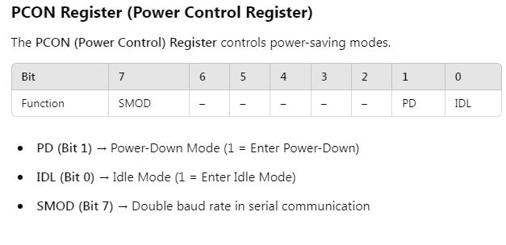

Solved Examples:
Example 1: Design a μController system using 8051 to Interface the external RAM of size 16k x 8.
Solution: Given, Memory size: 16k
Which means, we require 2^{n}=16k: n address lines
- Here n=14: A0 to A13 address lines are required.
- A14 and A15 are connected through OR gate to CS pin of external RAM.
- When A14 and A15 both are low (logic ‘0’), external data memory (RAM) is selected.

Address Decoding (Memory Map) For 16k X 8 Ram

Addr ess | A1 5 | A1 4 | A1 3 | A1 2 | A1 1 | A1 0 | A 9 | A 8 | A 7 | A 6 | A 5 | A 4 | A 3 | A 2 | A 1 | A 0 | Hex Addr
Start | 0 | 0 | 0 | 0 | 0 | 0 | 0 | 0 | 0 | 0 | 0 | 0 | 0 | 0 | 0 | 0 | 0000  H
End | 0 | 0 | 1 | 1 | 1 | 1 | 1 | 1 | 1 | 1 | 1 | 1 | 1 | 1 | 1 | 1 | 3FF  FH
Figure 5.6.3 shows interfacing of 16k x 8 RAM to 8051.

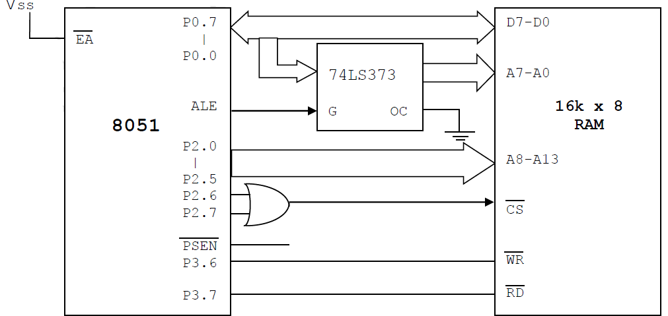

Figure 5.6.3 16Kx8 Memory (RAM) Interfacing with 8051
[Source: “The 8051Microcontroller and Embedded Systems: Using Assembly and C” by Mohamed Ali Mazidi, Janice Gillispie Mazidi, Rolin McKinlay]
Example 2: Design a μController system using 8051 to interface the external ROM of size 4k x 8.
Solution: Given, Memory size: 4k
i.e we require 2^{n}=4k :: n address lines
- Here n=12 :: A0 to A11 address lines are required.
- Remaining lines A0, A0, A0, A0 & PSEN are connected though OR gate to CS & RD of external ROM.
- When A0 to A0 are low (logic ‘0’), only then external ROM is selected.

Address Decoding (Memory Map)for 4k x 8 RAM
Addr ess | A1 5 | A1 4 | A1 3 | A1 2 | A1 1 | A1 0 | A 9 | A 8 | A 7 | A 6 | A 5 | A 4 | A 3 | A 2 | A 1 | A 0 | Hex Addr
Start | 0 | 0 | 0 | 0 | 0 | 0 | 0 | 0 | 0 | 0 | 0 | 0 | 0 | 0 | 0 | 0 | 0000  H
End | 0 | 0 | 0 | 0 | 1 | 1 | 1 | 1 | 1 | 1 | 1 | 1 | 1 | 1 | 1 | 1 | 0FF  FH

Figure 5.6.4 shows interfacing of 4k x 8 ROM to 8051

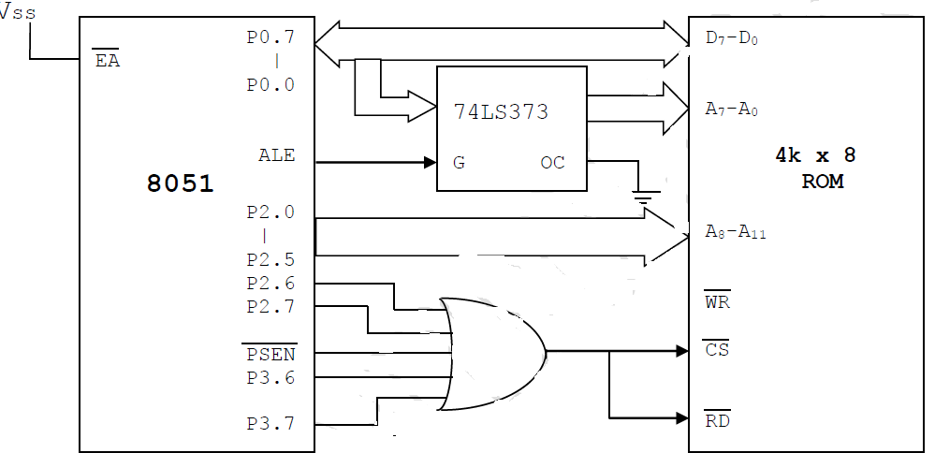

Figure 5.6.4 4Kx8 Memory (ROM) Interfacing with 8051
Example 3: Design a μController system using 8051, 16k bytes of ROM & 32k bytes of RAM. Interface the memory such that starting address for ROM is 0000H & RAM is 8000H.

Solution:
Given, Memory size- ROM : 16k
i.e we require 2^{n}=16k :: n address lines
Here n=14 :: A0 to A13 address lines are required. A14,A15,PSEN ORed CS when low – ROM is selected Memory size- RAM :32k
i.e we require 2^{n}=32k :: n address lines
Here n=15 :: A0 to A15 address lines are required.
A15 inverted(NOT Gate) CS when high- RAM is selected. For RAM selection
- PSEN is used as chip select pin ROM.
- RD is used as read control signal pin..
- WR is used as write control signal pin.

Address Decoding (Memory Map) for 16k x 8 ROM.

Addr ess | A1 5 | A1 4 | A1 3 | A1 2 | A1 1 | A1 0 | A 9 | A 8 | A 7 | A 6 | A 5 | A 4 | A 3 | A 2 | A 1 | A 0 | Hex Addr
Start | 0 | 0 | 0 | 0 | 0 | 0 | 0 | 0 | 0 | 0 | 0 | 0 | 0 | 0 | 0 | 0 | 0000  H
End | 0 | 0 | 1 | 1 | 1 | 1 | 1 | 1 | 1 | 1 | 1 | 1 | 1 | 1 | 1 | 1 | 3FF  FH

Address Decoding (Memory Map) for 32k x 8 RAM.

Addr ess | A1 5 | A1 4 | A1 3 | A1 2 | A1 1 | A1 0 | A 9 | A 8 | A 7 | A 6 | A 5 | A 4 | A 3 | A 2 | A 1 | A 0 | Hex Addr
Start | 1 | 0 | 0 | 0 | 0 | 0 | 0 | 0 | 0 | 0 | 0 | 0 | 0 | 0 | 0 | 0 | 8000  H
End | 1 | 1 | 1 | 1 | 1 | 1 | 1 | 1 | 1 | 1 | 1 | 1 | 1 | 1 | 1 | 1 | FFF  FH

Figure 5.6.5 shows the interfacing of 16Kx8 Memory (ROM) and 32Kx8 RAM with 8051

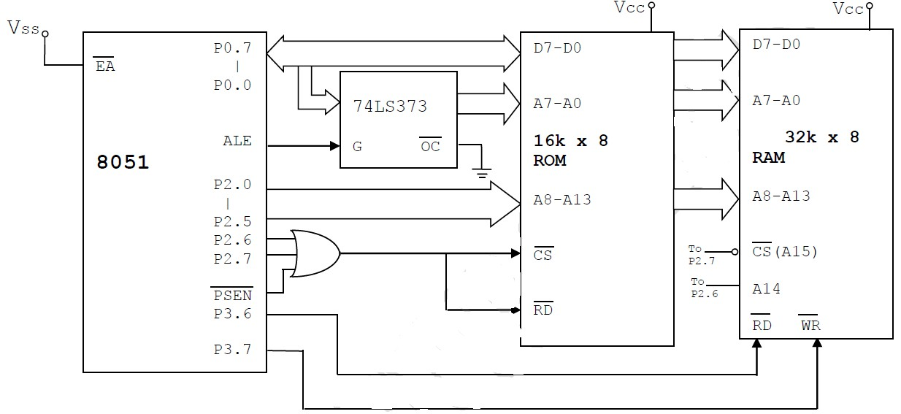

Figure 5.6.5 16Kx8 Memory (ROM) and 32Kx8 RAM Interfacing with 8051

